VoIP Gateway

📞 What is a VoIP Gateway?
# Source: Chatgpt (GPT‑5 Mini) at [12/18/2025]
A VoIP Gateway (Voice over IP Gateway) is a network device that converts voice traffic between traditional phone systems (analog or digital) and IP networks (like the internet). It enables communication between legacy phone systems (like landlines) and modern VoIP systems (like Zoom, SIP, or Microsoft Teams).
✅ In simple terms: A VoIP Gateway acts as a bridge between old telephone systems and new IP-based voice networks.

🔄 What It Does
# Source: Chatgpt (GPT‑5 Mini) at [12/18/2025]
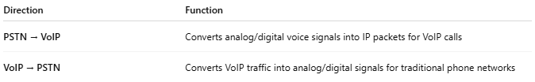
Direction | Function
PSTN → VoIP | Converts analog/digital voice signals into IP packets for VoIP calls
VoIP → PSTN | Converts VoIP traffic into analog/digital signals for traditional phone networks

🧱 Example Setup
# Source: Chatgpt (GPT‑5 Mini) at [12/18/2025]
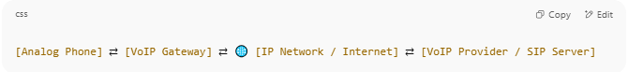
[Analog Phone] ⇄ [VoIP Gateway] ⇄ 🌐 [IP Network / Internet] ⇄ [VoIP Provider / SIP Server]

OR
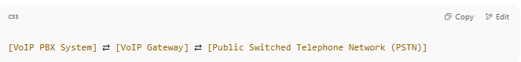
[VoIP PBX System] ⇄ [VoIP Gateway] ⇄ [Public Switched Telephone Network (PSTN)]

🧠 Types of VoIP Gateways
# Source: Chatgpt (GPT‑5 Mini) at [12/18/2025]
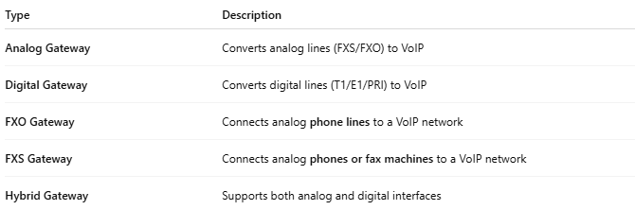
Type | Description
Analog Gateway | Converts analog lines (FXS/FXO) to VoIP
Digital Gateway | Converts digital lines (T1/E1/PRI) to VoIP
FXO Gateway | Connects analog phone lines to a VoIP network
FXS Gateway | Connects analog phones or fax machines to a VoIP network
Hybrid Gateway | Supports both analog and digital interfaces

🧩 Key Features
# Source: Chatgpt (GPT‑5 Mini) at [12/18/2025]
- 🔄 Signal conversion (analog/digital ↔ VoIP)
- 📞 Call routing and dialing rules
- 🔐 SIP protocol support for IP calls
- 🎚️ Echo cancellation, jitter buffering, and voice compression
- 🔊 Fax over IP (FoIP) support

✅ Advantages
# Source: Chatgpt (GPT‑5 Mini) at [12/18/2025]
- ✅ Enables existing phone systems to work with VoIP
- ✅ Saves money by avoiding full infrastructure replacement
- ✅ Smooth transition from PSTN to VoIP
- ✅ Centralized control over voice traffic
- ✅ Compatible with SIP-based VoIP platforms

❌ Disadvantages
# Source: Chatgpt (GPT‑5 Mini) at [12/18/2025]
- ❌ Requires some technical configuration (SIP, codecs, dial plans)
- ❌ May introduce latency or voice quality issues if not properly configured
- ❌ Adds an extra point of failure if not monitored

🏷️ Popular VoIP Gateway Vendors
# Source: Chatgpt (GPT‑5 Mini) at [12/18/2025]
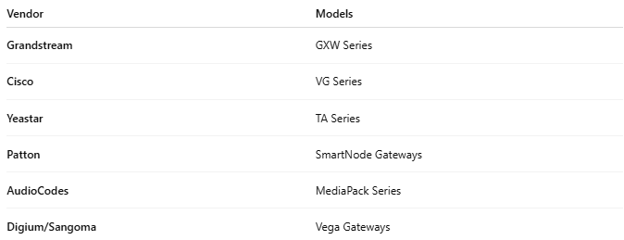
Vendor | Models
Grandstream | GXW Series
Cisco | VG Series
Yeastar | TA Series
Patton | SmartNode Gateways
AudioCodes | MediaPack Series
Digium/Sangoma | Vega Gateways

📌 Summary
# Source: Chatgpt (GPT‑5 Mini) at [12/18/2025]
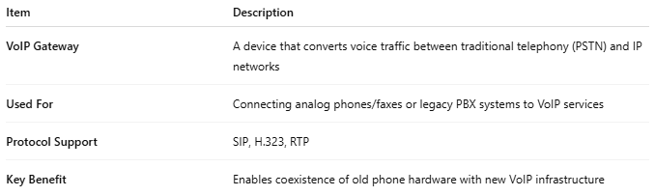
Item | Description
VoIP Gateway | A device that converts voice traffic between traditional telephony (PSTN) and IP networks
Used For | Connecting analog phones/faxes or legacy PBX systems to VoIP services
Protocol Support | SIP, H.323, RTP
Key Benefit | Enables coexistence of old phone hardware with new VoIP infrastructure

